Institute of Information Technology, Noakhali Science and Technology University

**Bachelor of Science in Software Engineering**

**Course Code: SE 4100**



**Internship Report**

**Submitted by**

*Md Al Adnan*

MUH1825008M

**Submitted to**

*Md. Iftekharul Alam Efat*

Chairman, Internship Placement Office

Assistant Professor, Institute of Information Technology (IIT)

Noakhali Science and Technology University

**Performed at**

*Kona Software Lab Limited*

Plaza Concord, 8th Floor, Tower - A  
Plot - 2, Road - 144, Dhaka 1212, Bangladesh

https://lh3.googleusercontent.com/4Myc7s4it_gUpFkTbF87wudKh5ZJzm0ZcZOLZSlnmiLA4elqy2tnb7zQBoCdtZI2e1tVqeZ_4c-bGeSoRdVAwLQyQyTWZ7zfCDYhJlzfAzP0IQ58AmC39QciFnsH-VlkhPUKPCCmhqVsHsWTE6TeU8J9DHWH3CuWwb_G9x3Tsv9HWIJn26nLPf8p

**Internship Attended:** March 15,2022 – September 20, 2022

**Date of Submission:** October 10, 2022

# 

# LETTER OF TRANSMITTAL

**October 10, 2022**

**The** **Chairman**

Internship Placement Office

Institute of Information Technology (IIT)

Noakhali Science and Technology University

Subject: **Letter of Transmittal**

**Dear Sir,**

This is a pleasure to submit the “Internship Report” as per Internship Program requirement for the course SE 4100 Internship.

This report contains gory details of my activities during the Internship period. I have been working as an intern at Kona Software Lab Limited. I was supervised by two individual Software Engineers of Kona Software Lab Limited, Shahidul Islam and Montasir Ahmed. I hope this report fulfils the requirements of Internship Program.

I am requesting you to accept and consider this report.

Yours sincerely

|  |
| --- |
| **Md Al Adnan**  MUH1825008M  Session: 2017-18  BSc. in Software Engineering Program  Institute of Information Technology (IIT)  Noakhali Science and Technology University |

# DECLARATION

**TO WHOM IT MAY CONCERN**

I, **Md Adnan**, bearing ID: MUH1825008MF, BSc. in Software Engineering Program, hereby declare that the presented “Internship Report” is uniquely prepared by me after completion of six months’ work in **Kona Software Lab Limited**.

My original work is submitted to Institute of Information Technology (IIT), Noakhali Science and Technology University, and no part of the report has been submitted for any other degree, or fellowship & the work has not been published in any journal or magazine.

|  |
| --- |
| **Md Al Adnan**  MUH1825008M  Session: 2017-18  BSc. in Software Engineering Program  Institute of Information Technology (IIT)  Noakhali Science and Technology University |

# LETTER OF ENDORSEMENT

**TO WHOM IT MAY CONCERN**

This is to certify that; **Md Al Adnan** was an intern at Kona Software Limited. During this period, I was one of his supervisors.

I hereby endorse that I have gone through the whole report. The contents of this report are true and not confidential to the company. The projects and training assignments mentioned in this report had successful participation of Md Al Adnan.

I wish him all the very best for his future life.

**Topu Newaz**

|  |  |  |
| --- | --- | --- |
| Head of Technology  Kona Software Lab Limited |  | EVP  Kona Software Lab Limited |

**Md Saiful Islam**

# 

# CERTIFICATE OF APPROVAL

This Internship report submitted by **Md Al Adnan, ID No: *MUH1825008M*** to the Chairman of Internship Placement Office, Institute of Information Technology (IIT), Noakhali Science and Technology University has been accepted as satisfactory for the partial fulfillment of the requirements for the degree of Bachelor of Science in Software Engineering and approved as to its style and contents. The presentation has been held on October, 2022.

**Internship Examination Committee:**

|  |
| --- |
| **Md. Iftekharul Alam Efat**, Chairman  Assistant Professor  Institute of Information Technology (IIT)  Noakhali Science and Technology University |
|  |
| **Dipok Chandra Das**, Committee Member  Assistant Professor  Institute of Information Technology (IIT)  Noakhali Science and Technology University |
|  |
| **Md. Eusha Kadir**, Committee Member  Lecturer  Institute of Information Technology (IIT)  Noakhali Science and Technology University |
|  |
| **Md. Hasan Imam**, Committee Member  Lecturer  Institute of Information Technology (IIT)  Noakhali Science and Technology University |

DEDICATION

I would like to dedicate my work to my family. They instilled in me a desire to learn and made sacrifices so I would have access to high quality education from an early age. Also, this is dedicated to my institute’s teachers who have always supported me throughout my years of studies.

TABLE OF CONTENTS

|  |  |  |  |  |  |  |  |
| --- | --- | --- | --- | --- | --- | --- | --- |
| Letter of Transmittal | | | | | | | I |
| Declaration | | | | | | | II |
| Letter of Endorsement | | | | | | | III |
| Certificate of Approval | | | | | | | IV |
| Dedication | | | | | | | V |
| Table of Contents | | | | | | | VI |
| List of Figures | | | | | | | XI |
| Offer Letter | | | | | | | XII |
| Acknowledgement | | | | | | | XIII |
| Preface | | | | | | | XIV |
| Executive Summary | | | | | | | XV |
|  | | | | | | |  |
| **Chapter One** | | | | | | |  |
| **Introduction** | | | | | | | 1 |
| 1.1 | Overview | | | | | | 1 |
| 1.2 | Origin of the report | | | | | | 1 |
| 1.3 | Objectives | | | | | | 2 |
| 1.4 | Scope of the report | | | | | | 2 |
| 1.5 | Methodology | | | | | | 2 |
| 1.6 | Limitations | | | | | | 3 |
| **Chapter Two** | | | | | | |  |
| **KONA I (Parent company)** | | | | | | | 5 |
| 2.1 | Introduction | | | | | | 5 |
| 2.2 | Business area | | | | | | 5 |
| 2.2.1 | | | Digital identification | | | | 6 |
| 2.2.2 | | | Payment platform | | | | 7 |
| 2.2.3 | | | Local community platform | | | | 7 |
| 2.2.4 | | | Mobility platform | | | | 7 |
| 2.2.5 | | | Block chain platform | | | | 7 |
| 2.2.6 | | | IoT platform | | | | 7 |
| 2.2.7 | | | Data platform | | | | 8 |
| 2.2.8 | | | Healthcare platform | | | | 8 |
| 2.3 | Business wing | | | | | | 8 |
| **Chapter 03** | | | | | | |  |
| **Company Profile** | | | | | | |  |
| 3.1 | | | Introduction | | | | 10 |
| 3.2 | | | Company history | | | | 10 |
| 3.3 | | | Governing body | | | | 11 |
| 3.4 | | | Technology | | | | 13 |
| 3.5 | | | Product & solutions | | | | 13 |
| 3.5.1 | | | | | | Digitization platform | 13 |
| 3.5.2 | | | | | | Smart card & personalization | 13 |
| 3.5.3 | | | | | | Security solution | 14 |
| 3.5.4 | | | | | | IoT platform service | 14 |
| 3.5.5 | | | | | | Enterprise solution | 14 |
| 3.6 | | | Life at KSL | | | | 14 |
| 3.6.1 | | | | | | Learning & professional growth opportunity | 14 |
| 3.6.2 | | | | | | Monthly team outing allowance | 15 |
| 3.6.3 | | | | | | Annual family tour | 15 |
| 3.6.4 | | | | | | Holidays & paid leave | 15 |
| 3.6.5 | | | | | | Transport facilities | 16 |
| 3.6.6 | | | | | | Breakfast lunch & snacks facilities | 16 |
| 3.6.7 | | | | | | Sports & Environment | 16 |
| 3.6.8 | | | | | | Dinning & prayer room | 17 |
| 3.6.9 | | | | | | Sprint planning | 17 |
| 3.6.10 | | | | | | Daily standup | 17 |
| 3.6.11 | | | | | | Friendly environment | 18 |
| 3.6.12 | | | | | | Inspiration | 18 |
| 3.6.13 | | | | | | Facilities for employees | 18 |
| 3.6.14 | | | | | | Dedicated workplace | 18 |
| 3.6.15 | | | | | | High speed internet | 18 |
| 3.6.16 | | | | | | Domestic environment | 18 |
| 3.6.17 | | | | | | Fun & passion | 18 |
| 3.6.18 | | | | | | Good bye session & gift | 19 |
| 3.7 | | | Departments | | | | 20 |
| 3.7.1 | | | | | | Admin | 20 |
| 3.7.2 | | | | | | IT support department | 20 |
| 3.7.3 | | | | | | Development department | 21 |
| 3.8 | | | Major clients | | | | 21 |
| 3.9 | | | Recruitment process | | | | 21 |
| **Chapter 04** | | | | | | |  |
| **Internship at KONASL** | | | | | | | 23 |
| 4.1 | | | Overview | | | | 23 |
| 4.1.1 | | | | First day at office | | | 24 |
| 4.2 | | | Appointment Letter | | | | 24 |
| 4.2.1 | | | | My desk | | | 24 |
| 4.2.2 | | | | Facilities for interns | | | 25 |
| 4.2.3 | | | | Conclusion | | | 25 |
| **Chapter 05** | | | | | | |  |
| **Assigned project** | | | | | | | 27 |
| 5.1 | | | Project description | | | | 27 |
| 5.2 | | | Techniques | | | | 27 |
| 5.2.1 | | | | | | HTML | 27 |
| 5.2.2 | | | | | | CSS | 27 |
| 5.2.3 | | | | | | JavaScript | 27 |
| 5.2.4 | | | | | | Java | 28 |
| 5.2.5 | | | | | | React | 28 |
| 5.2.6 | | | | | | Gradle | 28 |
| 5.3 | | | Libraries & frameworks | | | | 28 |
| 5.3.1 | | | | | | JQuery | 28 |
| 5.3.2 | | | | | | Spring boot | 28 |
| 5.3.3 | | | | | | Toast UI grid | 29 |
| 5.3.4 | | | | | | TestNG | 29 |
| 5.4 | | | Tools | | | | 29 |
| 5.4.1 | | | | | | IntelliJ IDEA | 29 |
| 5.4.2 | | | | | | GIT Lab | 29 |
| 5.4.3 | | | | | | Data grip | 29 |
| **Chapter 06** | | | | | | |  |
| **My Contributions** | | | | | | | 31 |
| 6.1 | | | Problem statement of project | | | | 31 |
| 6.1.1 | | | | | My responsibility | | 31 |
| 6.1.2 | | | | | Team | | 31 |
| 6.1.3 | | | | | Tools & technology | | 31 |
| 6.1.4 | | | | | Challenges | | 32 |
| 6.2 | | | Problem statement of second project | | | | 32 |
| 6.2.1 | | | | | My responsibility | | 32 |
| 6.2.2 | | | | | Team | | 32 |
| 6.2.3 | | | | | My Contributions | | 32 |
| 6.2.4 | | | | | Tools | | 32 |
| 6.2.5 | | | | | Challenges | | 32 |
| 6.2.6 | | | | | Conclusion | | 32 |
| 6.3 | | | Problem statement of third project | | | | 33 |
| 6.3.1 | | | | | My responsibility | | 33 |
| 6.3.2 | | | | | Team | | 33 |
| 6.3.3 | | | | | My Contributions | | 33 |
| 6.3.4 | | | | | Tools | | 33 |
| 6.3.5 | | | | | Challenges | | 33 |
| 6.3.6 | | | | | Conclusion | | 33 |
| **Chapter 07** | | | | | | |  |
| **Technical & Professional Growth** | | | | | | | 35 |
| 7.1 | | Technical Growth | | | | | 35 |
| 7.2 | | Tools | | | | | 35 |
| 7.2.1 | | | | | | Postman | 35 |
| 7.2.2 | | | | | | JMeter | 35 |
| 7.2.3 | | | | | | Jira | 35 |
| 7.2.4 | | | | | | Spring boot | 35 |
| 7.2.5 | | | | | | Selenium | 35 |
| 7.2.6 | | | | | | React | 35 |
| 7.3 | | Professional skill I learned | | | | | 36 |
| 7.3.1 | | | | | | Development technique | 36 |
| 7.3.2 | | | | | | Project deployment | 36 |
| 7.3.3 | | | | | | No bullying & blaming | 36 |
| 7.3.4 | | | | | | Respect for each other | 36 |
| 7.3.5 | | | | | | Attitude | 36 |
| 7.3.6 | | | | | | Planning | 37 |
| **Chapter 08** | | | | | | |  |
| **Team outing** | | | | | | | 39 |
| 8.1 | | Introduction | | | | | 39 |
| 8.1.1 | | | | Team outing at toggi fun world | | | 39 |
| 8.1.2 | | | | Team outing at fantasy kingdom | | | 39 |
| 8.1.3 | | | | Team outing at yamcha district | | | 40 |
| 8.1.4 | | | | Team outing at café rio | | | 40 |
| **Chapter 09: Self-assessment** | | | | | | | 42 |
| **Chapter 10: Conclusion** | | | | | | | 45 |

LIST OF FIGURES

|  |
| --- |
| Figure 1 Different types of smart card 06 |
| Figure 2 KSL business wings across the world 08 |
| Figure 3 Honarable persons of KSL 11 |
| Figure 4 Organization stucture of KSL 12 |
| Figure 5 Business unit structure of KSL 12 |
| Figure 6 Monthly team outing with team 15 |
| Figure 7 Playing table tennis 16 |
| Figure 8 Play station in KSL 17 |
| Figure 9 Fun time with team 19 |
| Figure 10 Goodbye session 19 |
| Figure 11 Farewell gift from team 20 |
| Figure 12 KSL major clients 21 |
| Figure 13 Appointment letter from KSL 24 |
| Figure 14 My office Desk 24 |
| Figure 15 Team outing at toggy fun world 39 |
| Figure 16 Team outing at fantasy kingdom 39 |
| Figure 17 Team outing at yamcha district 40 |
| Figure 18 Team outing at care rio 40 |

# OFFER LETTER

# ACKNOWLEDGEMENT

Firstly I would like to express my gratitude to the Institute of Information Technology and the Intern Placement Office for this internship program which was undoubtedly a great experience for me.

Special love to Md. Iftekharul Alam Efat sir, Assistant Professor of Institute of Information Technology, Noakhali Science and Technology University for giving me the opportunity to work as an intern in this organization.

I would like to thank Auhidur Rahman Sumon Sir, Assistant Professor of Institute of Information Technology, Assistant Professor, for guidance in resume writing to managing KSL for us.

I am grateful to KSL for recruiting me as an intern. I want to express my significant appreciation and profound respect to Md. Saiful Islam, Head of Technology, KSL for his praiseworthy observation and direction during the entire internship period.

I also want to express my gratitude to shahidul islam, Project supervisor and Engineering Manager of KSL, for cordial support and valuable guidance.

Finally I would like to thank all my team members – Rahat Uddin Azad, Anwar Kabir Sajib, Kazi Ziaul Houque, Montaser Majid, Nieb Hasan Neom and every other individual from KSL for making my adventure journey of internship period smooth and noteworthy. I am likewise grateful to them.

# PREFACE

The internship is an integral part of the Bachelor of Science in Software Engineering program of Institute of Information Technology, Noakhali Science and Technology University . The motivation behind this work term is to provide valuable insights into the professional and industry-oriented side of Software Engineering.

This report is the result of a five months long internship program carried out in Kona Software Lab Ltd. and is prepared as a requirement for the achievement of the Bachelor of Science and Software Engineering (BSSE) program of IIT.

This document contains the internship period I had from 16th May 2022- 30th September, 2022 at Kona Software Limited as a Software Engineer trainee. This document contains ten chapters that explain different aspects of experience I got through the internship period. Therefore this contains basic information internship establishment and descriptive information on the internship I got and my opinions on the overall internship period considering the whole experience.

The first chapter of this report contains the origination, objectives, data sources and the scope of discussion of this report.

In the second chapter, the companies’ parent profile is described. Which is KONA I- a korea based fintech company. Their overview, project types and business wings have been described.

In the third chapter it contains the history of Kona Software Lab Ltd for the past nine years, company overview, office environment, technical expertise and a short description of ongoing projects.

Fourth Chapter describes the project I worked on. Its descriptions, technologies, tools, and the features I have worked on.

In the fifth chapter I have described the ultimate outcome during these 6 months in KSL. What tools and technologies I am introduced and achieved.

In the six chapter I have described my contribution of KSL. In seven chapter I have showed some team outings with my team. In eight chapter I have describer technical and professional growth, In nine chapter I have discuses my self-assessment and in chapter ten I have describer conclusion.

# EXECUTIVE SUMMARY

Main purpose of my internship had exposed to the job world. Being an intern, the principal challenge was to make an interpretation of the theoretical and practical idea into real life experience. This internship program helped me to get and arrange detail learning at work duty. Internships experiences encounters made me increasingly focused in the activity advertise.

In addition, picking up presentation and involvement in the field, I have been giving a chance to check whether the specific professional field is the correct one dependent on getting individual involvement in the field. This Internship has helped me for developing the employer-valued skills, for example, cooperation, correspondences and attention to detail. It has illuminated me with the environment of professional development practice of software companies.

During my Internship at Kona Software Lab Limited, I have learned more about my field and industry, applied knowledge learned in the classroom, gained valuable work experience that will

help me to decide if this is the right path for me. Before going to Kona Software Lab Limited, I had no idea about real world working environment, teamwork or working procedure. After Joining with the team as an intern and continuing working, I have learned a lot about real life testing environment of an IT firm.

**Chapter 01**

Introduction

0

# 

# Chapter 01: Introduction

## 1.1 Overview

Institute of Information Technology (IIT), Noakhali Science and Technology University started its journey in January 2018 to create efficient manpower on information technology. IIT currently offers Bachelor of Science in Software Engineering – BSSE and Post Graduate in Information Technology (PGDIT).

The BSSE program is a four-year industry-oriented degree. The purpose of this program is to groom students in such a way that they become world class software engineers. This degree consists of 8 semesters (6 months/semester) of study. From very basic (structured programming, statistics, object-oriented programming etc.) to advanced courses (design pattern, security, operating system etc.) are taught during the first 6 semesters. After a long and hard journey of first 6 semesters, the most exciting and awaited semester starts which is internship.

As an internee we get in touch learning the practical implementation of theoretical knowledge with real life projects. It gives us solid ideas about the current trending technologies. We get a clue what knowledge we are lacking behind compared to other employees. We get an opportunity to learn the best practices of experienced developers and their lifestyle. How to lead a professional life and what the way employees communicate with each other while working as a group member. Designation hierarchy of an organization became familiar with students. Sense grows about the different roles and responsibilities within an organization. At the end a student develops strong communication skills and prepares himself for working in real life.

After completing my 6 semesters I was also offered an internship program at Kona Software Lab Ltd.(KSL)- a business wing of KONA I. This internship program helped me to relate my knowledge in real life projects. I tried to learn industrial culture and practice my level best.

## 1.2 Origin of the report

To evaluate the students' learning throughout the internship period. Students were instructed to submit a report on their internship program experience. This report tries best to present my company as well as my learning and professional growth. To present the company this report includes its parent company introduction, its projects, culture, environment etc.

## 1.3 Objectives

This report delivers its reader facts and insights about these following objectives:

* To represent the valuable experience gained through the internship program
* To mention the industrial practices, I have learnt
* To describe the technical skills, I have acquired
* To describe the tasks, I have accomplished
* To describe the real-life projects, I was involved
* To highlight the technologies and the software development process adopted by KSL.
* To present the services provided by KSL
* To describe the environment of KSL

## 1.4 Scope of the report

This report represents the experiences and learnings I have earned throughout the 6-months long internship program. I focused on my involvements and my experience of working in real life projects. How team members work together in a real life project, how the team members play their individual role, the process of adaptation with the company culture and technologies are described here. The company profile of KSL and its culture are also briefly discussed here. The report concludes with the description of my technical and professional growth after the internship program.

## 1.5 Methodology

The report is prepared from my personal experience at KSL as an intern and collecting information from websites and documents provided by personnel of the company. The resources of collected data are given below:

* Personal experience and observation gathered from different events and activities at KSL.
* Collaboration with teammates and colleagues.
* Seminars attended where the employees used to discuss about current technologies
* KSL official website.
* KSL policy guides.
* Listening from HR and project manager

## 1.6 Limitations

Information is provided in this report with respect to company policies and taking permission from the authority, as the company policy is highly sensitive about sharing internal information outside of the company. So I am bound to present my project involvement in brief. I am not allowed to discuss the technical details here.

**Chapter 02**

KONA I (Parent Company)

# Chapter 02: KONA I (parent company)

## 2.1 Introduction

KONA I Co Ltd is a South Korea-based company with headquarters located in Yeongdeungpo-gu, Seoul, South Korea. Company started back in 1998. It is an information technology based company that provides solutions and platforms to the global Fintech market. It provides IC (Integrated Circuit) chips to the banking, telecommunication and government sectors. The company also focuses on providing IoT (Internet of Things), smart card, authentication and security services. Its product and services consist of chip module supply, local payment, PKI (Public Key Infrastructure), secure server and others. The company operates in almost 90 countries in the world including Bangladesh.

## 2.2 Business Area

KONA I is currently operating their business based on various types of services which we can divide into six major categories. Those categories and their little description are provided in the next subsections.

## 2.2.1 Digital Identification

Kona supplies security modules with KONA I's chip OS and applet to card manufacturers and issuers around the world.

* + Smart IC Chip
  + Smart Card
  + Electronic Card
  + Authentication Services

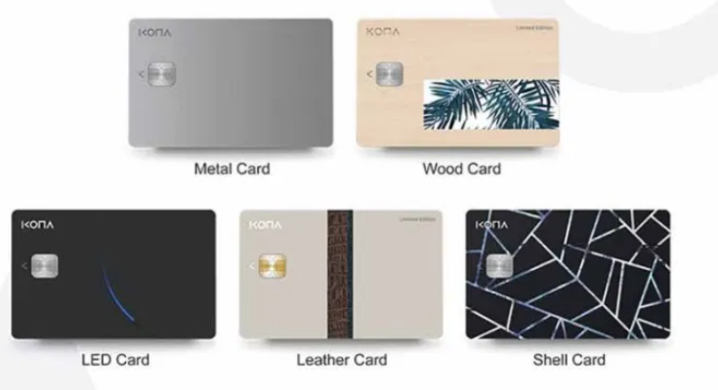

Figure 1-: Different types of smart cards

KONA I provides smart IC chips to the financial, telecommunication and public sector along with its security modules. It supplies smart cards such as metal card, gold card, eco-friendly card, LED card, PVC card, leather card, e cozen card etc. and KONA also supplies electronic cards such as fingerprint card, display OTP / Dynamic CVV card etc.

### 2.2.2 Payment platform

The KONA payment platform is an integrated marketing platform that combines payment systems with marketing services for customer relations. It allows its partner to build their own payment system with minimal cost and investment. Card types are:

* KONA Card
* KONA Benefits Card
* KONA Affiliate Card

People can use rechargeable Kona cards and businesses can have their customized cards like benefit cards and their own brand card which is called affiliate card.

### **2.2.3 Local Community Platform**

* Local Currency
* Local Community Service

Local currency is a currency created based on consensus among community members and can only be paid within the region. Kona provides a local currency type card that uses 56 local governments across the country. Local community services include local currency based food delivery, taxi call service, local molls, voting service etc. Users can get benefits by discount, coupons, cashback etc.

**2.2.4 Mobility Platform**

KONA I has been researching on core technologies for big data and mobility platform to provide mobility service such as:

* Delivery Service
* Taxi Call Service

These services enrich local community life and local residents.

**2.2.5 Block chain Platform**

* Kona Chain: Kona Chain is an enterprise block chain platform solution based on hyper ledger Fabric.
* Deep Service: Deep service is based on block chain technology, it protects user personal information, so that user can freely express his opinions. Transparency and security of the results are guaranteed.

**2.2.6 IoT platform**

Three types of IoT (Internet of Things) service KONA currently have.

* KONA DM & FOLTA: using the DM & FOTA global standard it is possible to combine many kinds of devices including mobile phones. This system provides a real-time secure and autonomous IoT platform.
* KONA Things Platform: It is an open API (Application Programming Interface) based IoT platform. It ensures scalability.
* KONA AMI Platform: AMI (Advance Metering Interface) is energy oriented IoT platform that provides remote meter reading, facility and data management.

### **2.2.7 Data Platform**

KONA I has been running over the past 20 years and it has a big collection of private and public data with various forms such as cards and finance. This data contributes to enriching KONA I's platform service. This data-based infrastructure provides various services such as real estate value information and issuance of various certificates.

### **2.2.8 Healthcare Platform**

KONA health is a digital healthcare service and its "AI Health Q'' shows the correlation between symptoms and diseases based on an AI algorithm. It also has a hospital, pharmacy recommendation system and customized health product shopping mall.

## 2.3 Business Wings

KONA I has international sales offices and technical centers in almost 40 countries across the world such as in the United States, China, India and Bangladesh as well as local offices in Nigeria and Brazil. KONA I's global network is the driving force capable of swift responding to the demand of the global markets. Some of the countries are listed below:

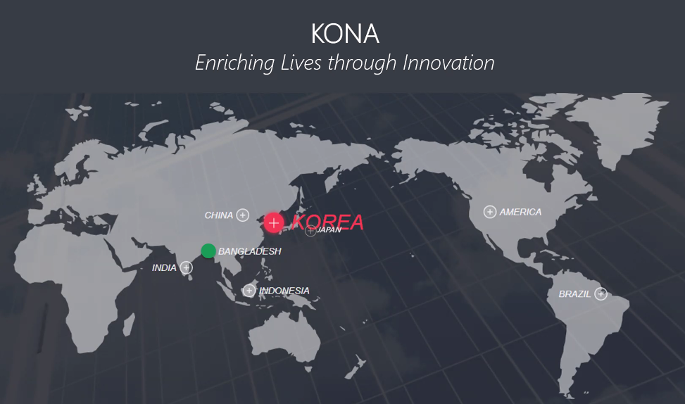

Figure 2-: KSL business wings across the world.

**Chapter 03**

Company Profile

# Chapter 03: Company Profile

## 3.1 Introduction

Kona Software Lab Ltd.(KSL) was founded in 2012. Since then KSL has been working as the R & D center and global solution business wing of KONA which has over 22 years of dominant international presence. Currently KSL consists of 120+ employees. It is located at the beautiful place at Hatirjheel Bridge, Gulshan-1. With its location, employee’s friendly behavior, enough hardware and internet facilities, food and entertainment makes its environments productive. It provides various business and security solutions as well as digital platforms. The notable business solutions are Nexus Pay and Nagad.

## 3.2 Company History

KSL history starts from 2012 when it started its journey. Since then KSL has gone through many changes and stages. This section discussed some of those stages briefly.

* 2012: KSL established as an R & D center of KONA I Co. Ltd.
* 2013: Formation of Payment Lab and Security Lab.
* 2014:
  1. Inception of Solution Business to conduct the sales and marketing activities of the solutions and platform products of the company.
  2. Developed Public Key Infrastructure (PKI) based products such as Middleware, Certificate Authority, Secure Mail with Digital Signature, Secure File Transfer and so on.
  3. Development of a Cloud-based Contactless Payment Platform based on the specification of international payment brands- VISA, MasterCard.
* 2015

1. Participated in Mobile World Congress in Barcelona, Spain to showcase the product of the company.
2. Launched Kona Pay Digitalization Platform in Seoul, South Korea.
3. Contract with the Transaction Security division of underwriters Laboratories, Singapore.
4. Partnership with Thales UK Limited.

* 2016
  1. Successfully migrated the MULTOS card platform of Dutch Bangla Bank Limited to Java card platform.
  2. Contract with Dutch-Bangla Bank Limited to deploy the first-ever Cloud-based Contactless payment platform in Bangladesh.
* 2017

1. Deploy Nexus Pay, the Host Card Emulation (HCE) based digital mobile wallet solution for Dutch-Bangla Bank Limited.
2. Piloted QR-based payment at the cafeteria of Bank Asia Limited.

* 2018
  1. Deploy the Digital Financial Service Platform (product of Bangladesh Post Office, Nagad) for Third Wave Technologies Limited(TWTL)
  2. Registered the Tokenization module of Kona Pay Digitalization Platform with EMVCo as Token Service Provider.

## 3.3 Governing body

I would like to introduce honorable three persons from whole governing body of KSL.

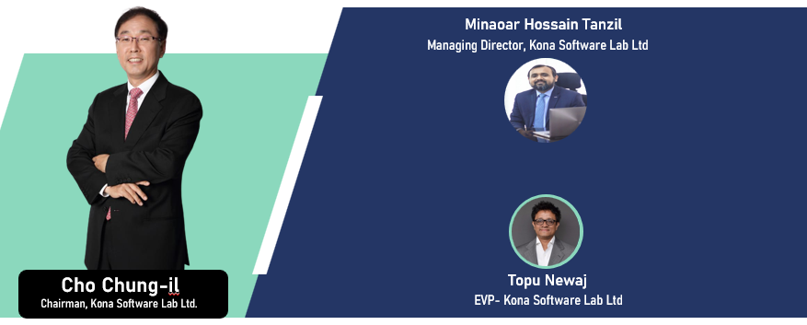

Figure 3-: Honorable persons of KSL

Cho Chung-il from Korea positioned as Chairman of KSL, Minoar Hossain Tanzil and Topu Newaj are from Bangladesh positioned as Managing Director and Executive Vice President respectively. Full organization chart given below.

Figure 4-: Organization structure of KSL

Figure 5-: Business unit structure of KSL

## 3.4 Technology

KSL is currently working on many projects as described in section 3.5, products and solutions.

Different technologies, frameworks and languages are being used here for different projects. Java as a Object Oriented Programming (OOP) language along with spring boot framework being used here almost all projects as backend applications tool. Raw JavaScript, JQuery library, Angular, React are also used for frontend development. Latest HTML (Hyper Text Markup Language) and CSS-3 are used for web page rendering and styling respectively. Be beep, Microsoft teams, Microsoft outlook, Gitlab, Git, Jira, Wiki sites are some of the frequently used tools in KSL.

## 3.5 Products & Solutions

## 3.5.1 Digitization Platform

* Kona Pay: Kona Pay digitization platform can digitize any payment and non-payment card as well as account (Bank card, Bank Account, Mobile Money Account etc.)
* Kona Card: This platform includes everything needed to run a card payment service on a single platform from the issuance of a card to the approval and settlement of transactions.
* Kona DFS: Kona Digital Financial Services (DFS) is a mobile phone-based financial services that is quite easy to avail and has board accessibility.

## 3.5.2 Smart Card and Personalization

Financial institutions need payment methods that are convenient and secure at the same time. Kona I offers various solutions sought by financial institutions at a reasonable price. So Kona I provides 5 services in this area.

1. EMV( International Payment Standard) card issuance product.
2. K-CPS(Kona Card Perso System) IC card issuance solution
3. K-IIS(Kona Instant Issuance Service) card issuance solution.
4. K-EVT is another solution with the advantage of checking correctness of data.
5. K-ECVS highly secured electronic card solution.

## 3.5.3 Security Solution

Government and public organizations need stronger security solutions to protect misuses of any official certificates and documents. Kona I's IC based ID card and relevant solutions (Health Card, E passport, International Driving License) meet all the security requirements.

## 3.5.4 IoT Platform Service

IoT platform uses DM & FOTA solution that applies to all devices including mobile creating unique value. It has enhanced security, All device support, real-time connection, open API and device update support. Home IoT and Things Platform are two major platforms based on IoT.

## 3.5.5 Enterprise Solution

Veaver: video based knowledge sharing service. This platform uses company videos that replace traditional document based working environments. It helps to manufacture, regenerate and share companies' valuable information assets and knowledge in an easier and safer manner with videos.

## 3.6 Life at KSL (Company environment and culture)

KSL considers the contribution of its people as the fuel of their innovation. Company respects countries' rules and culture. They observe every special day with nice decorations, special foods and events. Here, in this section some facilities are listed.

## 3.6.1 Learning and Professional Growth Opportunity

Kona SL is an ample opportunity for learning and professional growth. Every fresher who joins KSL must go through some learning process. Some latest technologies are a new concern at KSL including micro service, block chain, and IoT. To ensure fresher’s have basic knowledge about those technologies, experienced developers at KSL take sessions on this topic. They provide assignments and after submission evaluation takes place. Besides attending these compulsory sessions, there are some optional topics such as security, git are presented by experienced developers. Anyone can join it and enrich their knowledge in that field.

## 3.6.2 Monthly Team Outing Allowance

A monthly allowance is given to all employees' of KSL considering their motivation for team building other than official works. This allowance is called team bonding allowance. The amount is BDT 1200 per month per employee. On a certain day fixed by the team leader they all go out to the nearest place such as a restaurant to spend this allowance money.

Figure 6-: Monthly Team outing with team

## 3.6.3 Annual Family Tour

An annual family tour is arranged to enrich and refresh KSLian’s minds. This tour takes place in some cool places in Bangladesh. It takes two or three days to complete this tour. During the tour all the employees stayed in a festive mood.

## 3.6.4 Holidays and Paid Leave

* + Weekly holidays: All Saturday and Sunday are treated as weekly holidays. However, different holidays are also applicable for employees providing service on roaster.
  + Public holidays: All the gazette holidays declared by the government of Bangladesh are treated as the official holidays of Kona SL.
  + Leave: All the employees of KSL are entitled for 16 days' total leave in each English calendar year with full pay with the approval of immediate superior and departmental head. This paid leave will not include weekly and public holidays.
  + Sick leave: An employee may apply for sick leave only when he is sick and unable to attend work. KSL has the provision of 14 days' Sick leave in a year. For prolonged illness, an employee can avail additional sick leave if it is needed.
  + Maternity leave: A female employee is granted maternity leave for a period of 120 days.

## 3.6.5 Transport Facilities

KSL provides transport facilities to all its employees'. Transport systems are provided in different routes. The official transportation timing is fixed. Entry time is 8:30 and exit time is 6:30.

## 3.6.6 Breakfast Lunch and Snacks

KSL provides complimentary breakfast between 8:30 to 9:30. It also provides subsidiary lunch between 12:30 to 2:30. In the evening KSL provides snacks. An employee can avail dinner if s/he stays in the office till 10 PM.

## 3.6.7 Sports & Entertainment

Every day, after 5 PM KSLian engage themselves playing indoor game table tennis.

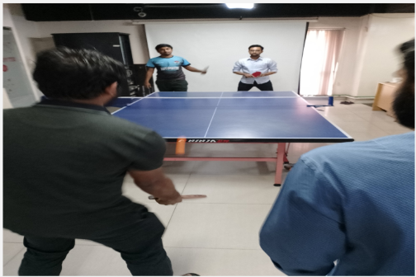

Figure 7-: playing table tennis

There is also a PlayStation where employees can enjoy playing various games such FIFA, Mortal Kombat, Need For Speed etc. KSL also attend intercompany cricket and football tournaments.

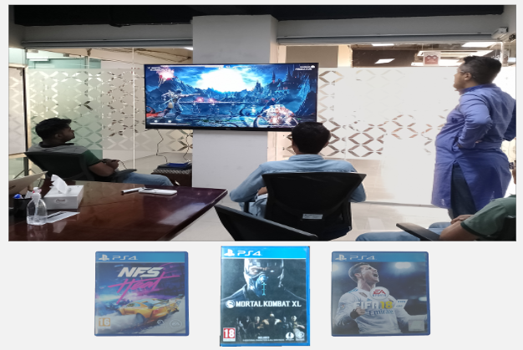

Figure 8-: PlayStation in KSL

## 3.6.8 Dinning and Prayer Room

The dining room is located at the old office of KONA buffet lunch is served to the employees with variations. The prayer room is also available in office premise.

### **3.6.9 Sprint Planning**

As mentioned above each team is closely managed by one Engineering manager. As KONA follows agile software development process, development phases are divided into sprints. Normally sprints contain two weeks that is 10 working days. At the starting of each sprint, development requirements are identified and the development process is planned in presence of all team members. After that the product engineering manager and team lead divide the sprint into small stories and breaks the small stories into tasks. Each task is assigned to individual team members and it is the duty of the team members to fulfill the task within given time schedule

## 3.6.10 Daily Stand Up

At the start of each working day daily stand up is hosted by engineering manager and all the team members are invited. Standup plays important role in development, as all team members clear their dependency of work with others. Each team member also needs to specify what he has done yesterday, what he will do today and if he needs any co-operation of other team members. As a result the whole team remains up to-date about the current status of their project and shares their knowledge themselves.

## 3.6.11 Friendly Environment

I had almost done 6 months as an intern in Kona. All the members did no differentiate us with other employees. All the members are very friendly. They help us to adapt with the new changes and challenges. And this friendly environment helps us to refresh our minds while working for hours.

## 3.6.12 Inspiration

The environment of KONA is really inspiring. Specially my team lead inspired me after each completion of every small task. This inspiration helps to become more focused to my work. Upper management also inspires the full team after successful client demos. Sometimes chief technical officer gives treat to the whole team and takes them to team event.

## 3.6.13 Facilities for Employees

High productivity of employee plays vital role in the economic development of an organization. Salary is only the hygiene factor of job satisfaction. Motivating factors influence the employee’s dedication towards his work. KONA provides various facilities to their employees –

**3.6.14 Dedicated Workplace**

Each employee is provided highly configured PC and laptop for development purpose and other staffs like notebooks, pen, first aid kits etc for their usage.

**3.6.15 High Speed Internet**

24 hour high speed internet facility is provided and all internal and external communication with clients and members are done through skype.

**3.6.16 Domestic Environment**

KONA is like a family of rock stars. They help each other not only in professional life but also in their personal life. Working here is fun and working for the company is individual’s responsibility.

**3.6.17 Fun and Passion**

All the employees are always connected with each other and share a special bond among them. Sometimes its about doing research and development, sometimes having errors in code, sometimes discovering new solutions to problems, sometimes planning for events or sometimes its just selfie time. Sometime for simple reasons we enjoy our time .

Figure 9-: Fun time with team

**3.6.18 Good Bye Session and gift**

All the members take part to buy gifts and surprise cards to wish any employee leaving the company. Sometimes they throw parties to say good bye. Everyone share his / her experience to work with me.

Figure 10-: Good bye session

Figure 11-: Farewell gift from team

## 3.7 Departments

**3.7.1 Admin**

There is a dedicated admin department consisting of 8-10 employees. The Admin department works across all departments and all kinds of work.

* Transport Management
* Human resource Management
* Food Management
* Salary management
* Events management

These are some common tasks which are managed by the admin department.

### **3.7.2 IT support department**

The IT support department maintains the computer networks within the company. This department provides technical support and ensures the whole company runs smoothly. New resource installment, Installing software, resolving network issues, setting up configuration etc. are maintained by the IT support department. Whenever an employee feels a technical issue with his computer he directly calls the IT support department by a software Microsoft Teams. In response to this call the IT support team resolves that issue physically or remotely whatever demands by the problem.

### **3.7.3 Development Department**

Employees of this department are called developers. They directly write software code. This department is split into different teams such as block chain team, QA team, machine learning team etc. Scrum meetings are held every morning by each team. Every team is responsible for developing a specific software project by collaborating with the team members. Designing, coding, testing, releasing are some jobs done by developers.

## 3.8 Major Clients

From history, we learned that KSL deals with lots of products and solutions from its journey in 2012. Till now 2022 KSL identified all of its clients as shown in this picture below.

Figure 12-: KSL major clients

## 3.9 Recruitment process

Fresher as well as experienced people can join KSL. Joining process is straightforward. People from different technologies are encouraged to submit an application. After primary screening applicants are called for some test process held at KSL premise.

* Written Test: this test includes some basic questions such as OOP concept, Security, Database etc.
* Hands-on Test: This test basically includes a programming test. Applicants are given some problems and expected to solve them using his convenient programming language.
* Technical Viva
* Final Viva

**Chapter 04**

Internship at KONA SL.

# Chapter 04: Internship at Kona Software Lab Limited

## 4.1 Overview

In our academic life we complete courses on different technologies and concepts. Within this short time it is not possible to apply this knowledge with actual industry practices. Thus internship as part of academic curriculum plays a vital role in the learning phase of a student. As I joined KONASL as an intern, I had not proper knowledge about industry practices. KONASL employees helped me to overcome this situation by guidelines and making me familiar with new tools to manage the overall process.

## 4.1.1 First Day at Office

When I got my joining date, I was extremely glad, yet as the date came closer, I was somewhat

Apprehensive. Numerous inquiries involved my cerebrum like in what manner will be the air of

the workplace, will I have the capacity to modify with the associates, will I have the capacity to

function admirably and completer targets, and so on. I came in at about 9:00 am on the first day

and my supervisor welcomed me warmly, introduced me to my colleagues and team lead. He

showed me where my desk was and told me that he and my colleague would help me get started.

He was very helpful always and I sat next to him for the morning and just watched what he did. At lunch, HR and the staff of the office invited me to lunch. I was so nervous; I could hardly

eat a thing! We were gone for about 1-1.5 hours and just talked about the company, my studies,

etc. After lunch, Neom bhai (software engineer). Introduced me to everyone, showed prayer place, all that good stuff and me where the kitchen was, how the coffee machine worked, where the copy machine was. My day ended at 6.00pm. It was a great first day.

## 4.2 Appointment Letter

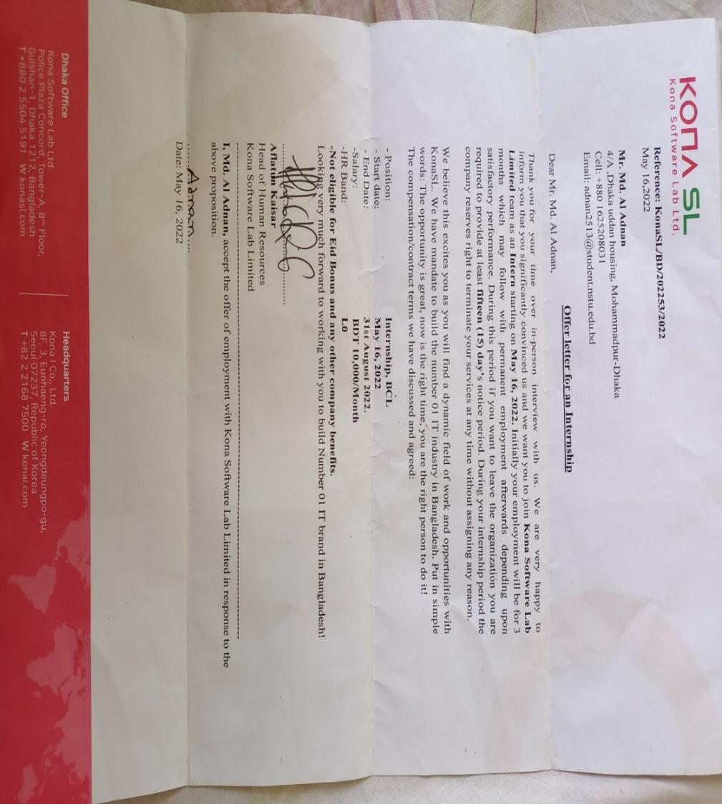

Figure 13-: Appointment letter from ksl.

## 4.2.1 My desk

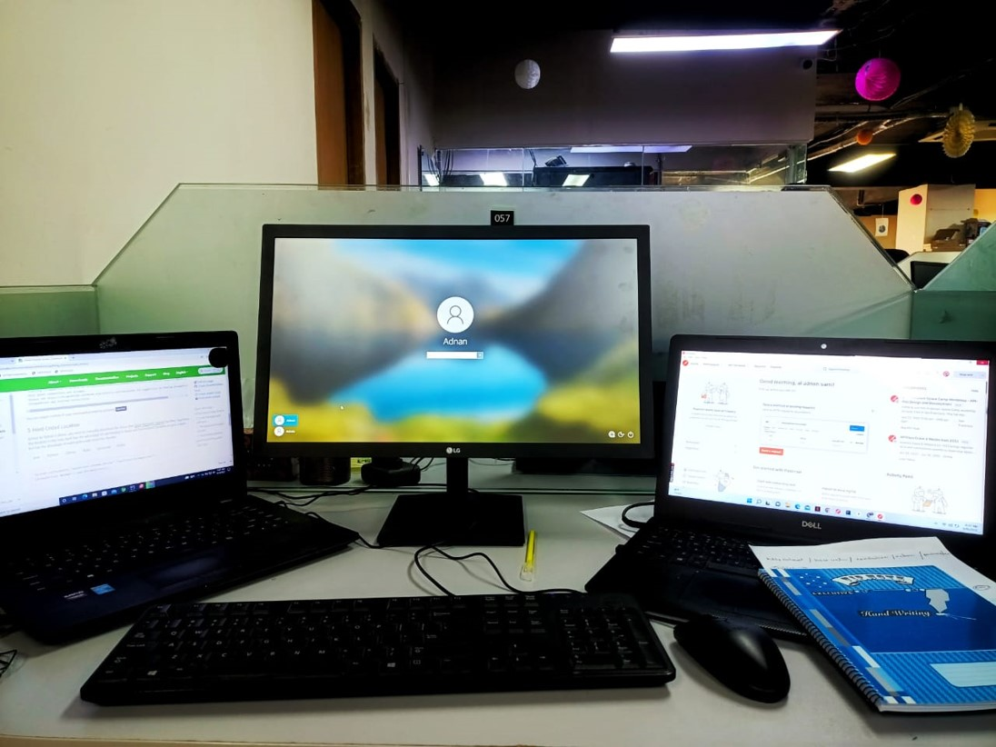

Figure 14-My office desk

## 4.2.3 Facilities for Interns

All the members of KONA welcomed us just like any new employee. We were introduced to the other employees. We were treated just like any other employee of KONA. In the first stage we were in close observation of company HR and he shared his knowledge with us and spent his valuable time to make us comfortable with the environment.

Following are some of the facilities that we were offered in KONASL

* Dedicated workspace like any other employee
* Individual PC and other facilities
* Healthy amount of remuneration
* Opportunity to get familiar with new tools
* Opportunity to work in real life project

## 4.2.3 Conclusion

After spending five months of my internship program, I would really appreciate the provided facilities and knowledge of KONASL. The procedure they adopted for intern management is really impressive. I am also thankful to IIT foe giving me this chance

**Chapter 05**

Assigned Project

# Chapter 05: Assigned Project (P2P An International Poject)

## 5.1 Project Description

Cryptrade is an online exchange platform where users can trade cryptocurrencies likes Bitcoin and etherum. Cryptrade provides a crypto wallet for traders to store their funds. Like other crypto exchanges, Cryptrade offers services like trading, sending coins, and receiving coins. Cryptrade has its own block chain-based token in its development phase named Kona coin.Users buy and sell cryptocurrencies though the website exchange of korean currency.

I joined Kona Software Lab Ltd. on 16 may 2022. After completing a one month introduction on spring boot, Unit testing , Knowledge about automation and project structure I am considered as one of the resources of their project.

## 5.2 Technologies

The technologies used by this project are described here.

### **5.2.1 HTML**

The Hypertext Markup Language or HTML is the standard markup language for displaying documents to web pages. HTML consists of a series of elements that describe the structure of a webpages. Elements just label a piece of content such as "this is h1 heading", " this is paragraph" etc. CSS and JS can be used to access HTML elements.

### **5.2.2 CSS**

Cascading style sheets(CSS) is a styling sheet that is used to customize the HTML element's appearance. CSS selectors or inline CSS can be used to access and design HTML elements.

### **5.2.3 JavaScript**

JavaScript, abbreviated as JS, is a programming language that is one of the core technologies of the world wide web, alongside HTML and CSS. It is a lightweight, interpreted, or just-in-time compiled programming language. In web JS is used providing functional behavior of documents. We can describe what will happen when a button is clicked, when mouse hover over a certain element, when keyboard starts typing etc. So JS makes the web page intractable, live. We can change CSS dynamically, request other sites bringing data, adding event handlers etc. The only limitation is our thinking ability.

### **5.2.4 Java**

Java is a general-purpose programming language that is class-based and object-oriented. The programming language is structured in such a way that developers can write code anywhere and run it anywhere without worrying about the underlying computer architecture. It is also referred to as write once, run anywhere (WORA).

### **5.2.5 React**

ReactJS is a declarative, efficient, and flexible JavaScript library for building reusable UI components. It is an open-source, component-based front end library which is responsible only for the view layer of the application. It was initially developed and maintained by Facebook and later used in its products like WhatsApp & Instagram.

### **5.2.5 Gradle**

Gradle is a build automation tool for multi language software development. Normally, after writing code we need to download dependency files, compile every class, link them together into a single file, adding resources and finally test and deploy code. Gradle automates this whole process. Gradle defines project structure such as where to write source classes, test classes, adding resources and provides a way describing required libraries. Gradle automatically download those dependency files, compile and build the project on behalf of developers. Developers just focus on coding.

## 5.3 Libraries And Frameworks

### **5.3.1 jQuery**

jQuery is a lightweight library of JavaScript functions. jQuery is considered as a ‘write less, do more’ JavaScript library. It makes things easier when working with HTML document traversal and manipulation, event handling, animation, and Ajax. The best part of jQuery is that It works the same way regardless of browser types.

P2P uses JQuery instead of raw JavaScript for building all the front-end modules.

### **5.3.2 Spring Boot**

Spring boot is an open source micro service-based Java web framework. Spring boot frameworks create a production-ready environment that is completely configurable with its pre-built code. Spring Boot uses spring security features that have built-in protection against common attacks. Spring provides an easy way of connecting and interacting with databases, creating REST APIs using MVC (Model View Controller) pattern. This is why the project uses Java and Spring Boot framework to develop its backend APIs. More about Spring Boot described in the next section.

### **5.3.3 Toast UI Grid**

The TOAST UI Grid is a component that can display, edit, add, and delete multiple data. The Grid is a powerful library with features like data editing, filtering, paging, sorting, and more, and can be used to customize the editor or the renderer to desired format.

### **5.3.4 TestNG**

TestNG is a testing framework for the Java programming language. In p2p project automation we used selenium testNg framework, For report generate we use allure report.

## 5.4 Tools

### **5.4.1 IntelliJ IDEA**

This project uses Intellij IDEA as an integrated development tool to get benefitted of its rich features. More about Intellij IDEA discussed in the next section.

### **5.4.2 GitLab**

GitLab is a web based git repository. GitLab has an issue tracker and wiki for each project. GitLab contains a built-in DevOps tool which is used to build, test and deploy securely our project.

### **5.4.3 Data Grip ( The Cross-Platform IDE for Database)**

Data Grip is a cross-platform Integrated development tool for database management. It is designed to query, create and manage databases. Location of the database can be a local or remote server. Data Grip supports MySQL, PostgreSQL, Oracle, Microsoft SQL server etc. Data Grip contains smart SQL editor editing queries. It can detect probable bugs in the database and suggest the best option to fix. Data Grip saves all the queries runed previously and provides a way to navigate history.

**Chapter 06**

My Contributions

# Chapter 06: My Contribution

## 6.1 Problem Statement of Project

In my learning phase I was working with internal projects assigned by company Head of Technology for making strong base for future development. I was assigned in a real life project named p2p. Because of large scale project it was a laborious task to test the full project. That’s why company felt the necessity to build up an automation tool to automate the full testing process.

## 6.1.1 My Responsibility

**My job description (role):** Software Automation Engineer.

* My daily activities was to improve automation added new automation field as per as developer needed
* Writing code for new feature and existing feature so than developer and SQA team can save their time.
* We Develop three version of automation testing tool.
* (General) First of all write Selenium (TestNg) code for running our code in happy path than refactor the code.
* (Excel Based) Secondly work with excel sheet automation where sheet are used to perform automation testing.
* (Dynamic) Thirdly fully backend project where automation is run by calling api (using postman).

## 6.1.2 Team

In the automation team we had three members Rahat Uddin Azad, Anwar Kabir Sajib and me. Also we had 22 others team member from developer, tester and engineering manager.

## 6.1.3 Tools & Technology

Following are the tools that I used while performing the above-mentioned responsibilities:

* Selenium
* Anum Processor
* Test Param
* Data aggregator
* VS Code
* Intellij IDEA

## 6.1.4 Challenges

* New Framework & Technology Learning (Like Spring boot, selenium TestNG , Data Aggregator, Allure Report)
* Maintaining large codebase.
* Structured Coding
* Coding without dependency

## 6.2 Problem Statement of Second Project

After 3 month later My manager assigned new task To estimate how many users can hit the application at a time we needed to do the load test.

## 6.2.1 My Responsibility

* Test the actual load for specific API
* Test the actual load for p2p users.

## 6.2.2 Team

I did the load test all by myself. And I generate the report and submitted it to Ruhit Ahmed(Software engineer) using Jira.

## 6.2.3 Tools

* JMETER

## 6.2.4 Challenges

* New Framework & Technology Learning(Like JMeter & Html Report)
* Load Test using customize API.

## 6.2.4 Conclusion

I learnt a lot through this time as I learnt new Framework and Technologies. And I also contributed my best for Kona Software Lab Limited

## 6.3 Problem Statement of Third Project

After 4 month later My manager assigned new task To all API gateway using POSTMAN.

## 6.3.1 My Responsibility and Contribution

* My responsibility was to learn basic idea and usage of Postman.
* Doing API testing using postman. API was provided by Zia bhai.
* I did more than 15 sites API testing with Postman.
* I submitted every testing report.
* I did GitHub API testing through Postman.

## 6.3.2 Team

I did the API test all by myself. And I generated the report and submitted it to Ruhit Ahmed(Software engineer) using Jira.

## 6.3.3 Tools

* POSTMAN

## 6.3.4 Challenges

* New Framework & Technology Learning(POSTMAN, NEWMAN)
* API reports uisung NEWMAN.

## 6.3.5 Conclusion

I learnt a lot through this time as I learnt new Framework and Technologies. And I also contributed my best for Kona Software Lab Limited

**Chapter 07**

Technical & Professional Growth

# Chapter 08: Technical & Professional Growth

# 7.1 Technical Growth

Technology helps track and streamline processes, maintain data flow and manage contacts and employee records. I have learnt a lot of new technologies and tools there. It is the best time to get familiar with all these and becoming confident about using this in my future career.

# 7.2 Tools

I learned about many new tools of testing. The most common tools we work with are:

## 7.2.1 Postman

Postman is an API platform for developers to design, build, test and iterate their APIs. Almost any functionality that could be needed by any developer is encapsulated in this tool. Firstly, we used to test API on with Postman and it was very easy to test with it. I learned Postman from [Postman Documentation.](https://learning.postman.com/docs/getting-started/introduction/)

## 7.2.2 JMeter

JMeter is an open-source testing tool from Apache that offers a wide range of performance testing capabilities. It is actually a java-based desktop application that allows testing of client-server applications like databases, FTP servers, websites, web services, etc. More importantly, it does not require you to pay any licensing costs. I learned JMeter from [JMeter Documentation.](https://jmeter.apache.org/usermanual/index.html)

## 7.2.3 Jira

Jira is a software application used for issue tracking and project management. Basically, I used this tool for bug reporting.

## 7.2.4 Spring Boot

Spring Boot is one of the Best Backend frameworks that developers count on while performing backend web development tasks. I learned spring boot for my p2p project.

## 7.2.5 Selenium

Spring Boot is one of the Best Backend frameworks that developers count on while performing backend web development tasks. I learned spring boot for my p2p project. I used google and YouTube for learning.

## 7.2.5 React

Spring Boot is one of the frontend frameworks that developers count on while performing frontend web development tasks. I learned react for my p2p project. I used google and YouTube for learning.

## 7.3 Professional skill I Learn

## Here I discussed what professional skills I learned during internship periods.

## 7.3.1 Development Technique

As a fresher when I started my development tasks I had a lots of confusions and questions. But as I mentioned KONASL follows agile process, whenever we get new challenges we have some buffer time to do some research and development activities. Our team lead and seniors are always there to influence our development skills. Daily scrum helps me to get up-to-date with the new technologies and the current status of the project. As the project is huge and everyone works in different modules, one does not have detail idea about another module. So knowledge sharing sessions are arranged among the team members.

## 7.3.2 Project Deployment

After every two weeks code would be merged and then deploy to QA server

## 7.3.3 No bullying and blaming.

Software development is always a team work. And when there is a team work, misunderstanding is very usual. However, I have never seen my team leaders and project managers to bully people working under their supervision. Personally, I have made a lot of mistakes last in five months. But my project manager had never been harsh with me. Blaming others for their mistakes does not solve the problem. It only makes the situation and the relationship between coworkers worse. My team lead always encouraged me in case of success and helped me to fix the problems in case of any failure.

## 7.3.4 Respect for Each Other

In a corporate environment respect for each other is a must. For gaining respect a person need to show respect to his fellow co-workers. Doing this creates a healthy environment among the members and a helping hand of seniors is always there for you.

## 7.3.5 Attitude

As an intern the attitude of my seniors attract me very much and I always try to follow them to be a successful Software Engineer as well as a successful man. They always know what to say and how to say, what is the right time for decision making or a change. Their entire attitude towards their profession, team members and most important their work influenced me a lot.

## 7.3.6 Planning

Planning at the starting of a day is a professional practice. I have seen all my seniors start their day by planning all their tasks for that specific day. My team lead always emphasizes us to resolve our blocking issues with one another at the starting of the day. It helps us to be stick to our sprint planning activities.

**Chapter 08**

Team Outing

# Chapter 08: Team outing

## 8.1 Introduction

KONASL offers monthly team outings for its employees .It is a mean of increasing collaboration, cooperation and creating healthy environment among its employees. P2P team was very energetic and hardworking.

## 8.1.1 Team outing at Toggi fun world

In Toggi Fun World it was my first team outing with my P2P team. Here we done some exciting gaming activities.

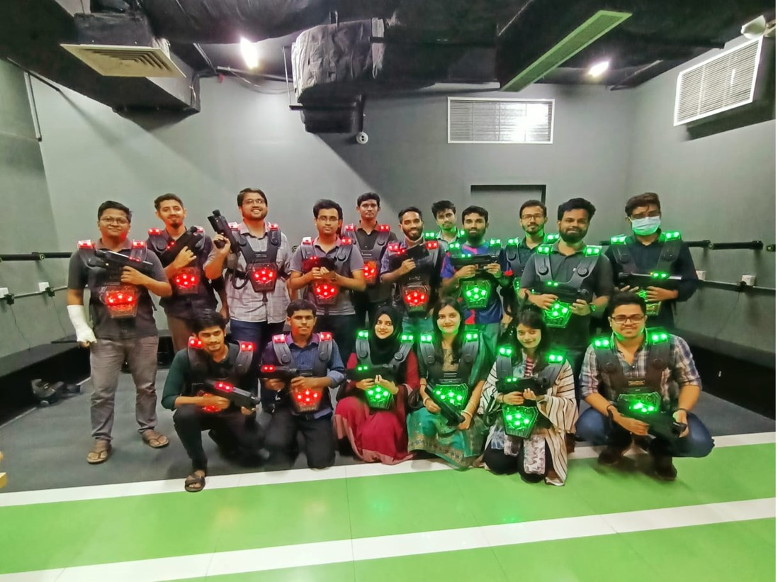

Figure 15-Team outing at toggy fun world.

## 8.1.2 Team outing at Fantasy kingdom

In Fantasy Kingdom it was my second team outing with my P2P team. Here we done some exciting gaming activities like santa maria, roller coster, Magic carpet.

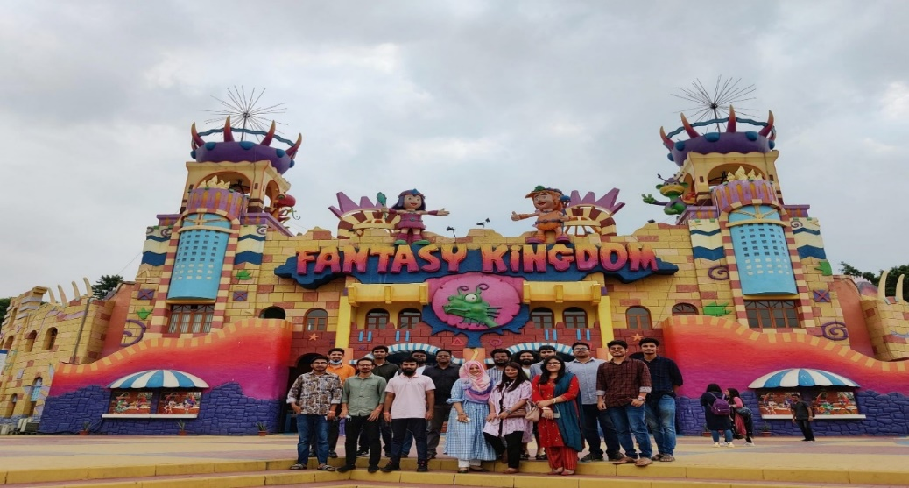

Figure 16:-Team outing at fantasy kingdom

## 8.1.3 Team outing at Yamcha district

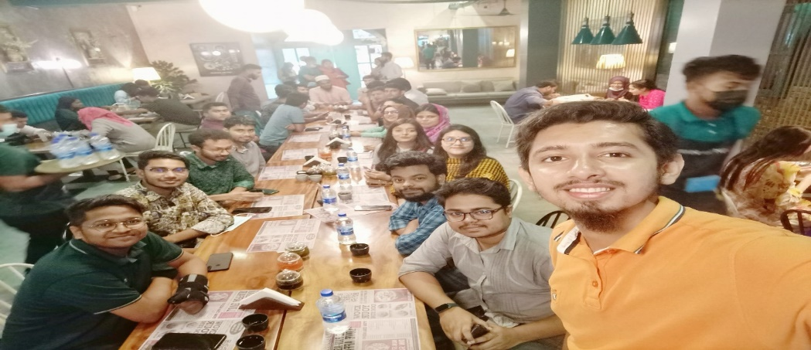

Figure 17:-Team outing at yamcha district

## 8.1.4 Team outing at CAFÉ-RIO

In this picture we can see my team lead, head of business, business analyst, SQA team and Manager.

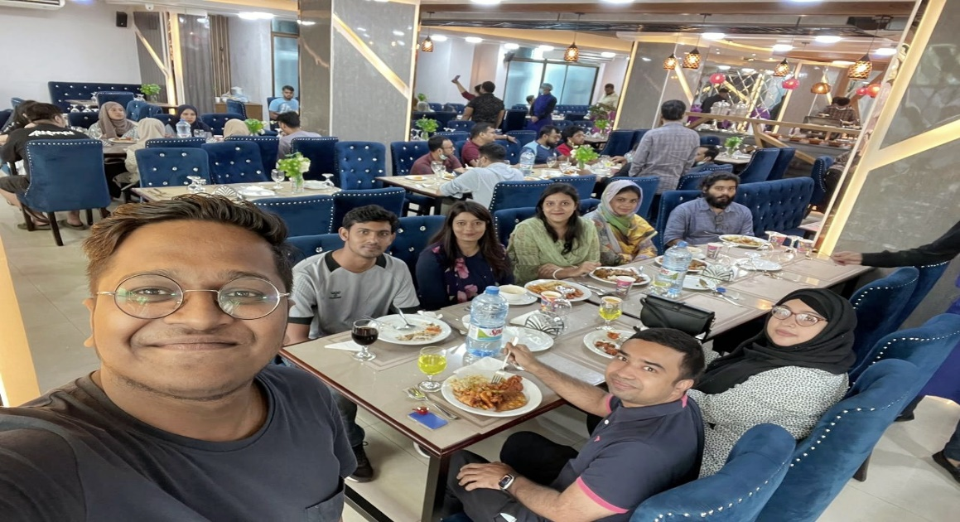

Figure 17-team outing at café rio.

**Chapter 09**

Self-Assessment

# Chapter 09: Self-Assessment

# 9.1 Overview

In the following part I will represent my viewpoint on my achievements as an intern. I will assess my abilities that I gained and nourish through my internship program. I tried to do best performance in my internship period but I need to learn many things that’s why I would give myself 47 out of 50 by following self-assessment form.

|  |  |  |  |  |  |  |
| --- | --- | --- | --- | --- | --- | --- |
|  | Outstanding  (5) | Very Good  (4) | Average  (3) | Needs Improvement  (2) | Poor  (1) | Sub-Total |
| 1. Punctuality  Attends work regularly and on time | √ |  |  |  |  | 5 |
| 2. Ability to Solve Problems  Skill and Duration to resolve issues |  | √ |  |  |  | 4 |
| 3. Accuracy of Work  To be accurate and precise at work | √ |  |  |  |  | 5 |
| 4. Creativity  How much ingenuity you have shown in work |  | √ |  |  |  | 4 |
| 5. Dedication  Produces the expected volume of work in scheduled time | √ |  |  |  |  | 5 |
| 6. Professionalism  Conduct, behavior and attitude at work or business environment | √ |  |  |  |  | 5 |
| 7. Team Work  Cope-up ability with team along with work distribution and helplines with others | √ |  |  |  |  | 5 |
| 8. Growth of New Technology  How frequent and adaptive in learning new tactics and technologies | √ |  |  |  |  | 5 |
| 9. Interpersonal Communication  Maintains effective two-way communication with staff, peers and supervisor | √ |  |  |  |  | 5 |
| 10. Leadership Skill  Takes initiative on project assignments and offers effective solutions for improving operations |  | √ |  |  |  | 4 |
| TOTAL  (out of 50) | | | | | | 47 |

Figure 18:- Self-Assessment form

## 9.1.1 Punctuality

Punctuality means the fact of arriving, doing something, or happening at the expected or correct time and not late. I give 5 out of 5 in Punctuality. Sometimes I faced huge traffic in road that’s why I could not attend office in time.

## 9.1.2 Ability to Solve Problems

Problem solving is an essential skill in the workplace and personal situations. Learn how to solve problems more effectively with our step-by-step guide. I give 4 out of 5 in ability to solve problems. Because I think I have good problem solving skills in testing

## 9.1.3 Accuracy of Work

Accuracy is defined as the quality or state of being correct or precise. Another definition of accuracy is the degree to which the result of a measurement, calculation, or specification conforms to the correct value or a standard. I give 5 out of 5 in accuracy of work. Because I tried to do everything right.

## 9.1.4 Creativity

Creativity, the ability to make or otherwise bring into existence something new, whether a new solution to a problem, a new method or device. I give 4 out of 5 in Creativity. Because I think I need to improve creativity.

## 9.1.5 Dedication

Dedication means the quality of being dedicated or committed to a task or purpose. I give 5 out of 5 in Dedication. Because I tried to level my best for my work

## 9.1.6 Professionalism

Professionalism is the conduct, behavior and attitude of someone in a work or business environment. In KONASL. I tried to be professional enough but I think I need to improve more. So I give 5 out of 5 in professionalism

## 9.1.7 Team Work

Teamwork is the collaborative effort of a group to achieve a common goal or to complete a task in the most effective and efficient way. I give 5 out of 5 in team work. Because in team work I tried to do work with team member professionally.

## 9.1.8 Growth of New Technology

I give 5 out of 5 in Growth of new Technology. Because when new tool arrive I cope up easily with this tool.

## 9.1.9 Interpersonal Communication

I give 5 out of 5 in Interpersonal Communication. Because I tried to maintain good communication with everyone.

## 9.1.10 Leadership Skill

I also give 4 out of 5 in Leadership skill. In our company when any task gave me I try to solve or I gave improvement of this task to our peers or superiors.

**Chapter 10**

Conclusion

# Chapter 10: Conclusion

The Internship program has enabled me to gain important knowledge on software industry, their culture, work environment and all about software quality assurance and testing. I feel proud to be a part of this valuable program of our academic syllabus. The credit also goes to our honorable teachers mainly **Md. Iftekharul Alam Efat** and the other faculties for such a successful completion of the internship program.

It completed fe months since my joining at KSL since 16-may-2022 to 30-September. I remember the very first day at KSL, the HR department took us to every lab and we were introduced as the youngest employees at KSL. Afterwards, Aflatun Kaisar, Chief of People Care, Kona Software Lab Ltd., told us that they do not expect too much from us. We should maintain office time, learn the environment & culture and enjoy other facilities. They keep their words throughout those five months. I never feel pressure by them or my project manager, Md. saiful Islam, Head of Technology, Kona Software Lab Limited. Again my cordial respect for them.

I joined a real project, P2P. This project was managed by Headquarter, Korea. We went through many discussions with them over online to get a clear understanding about what we are going to develop. Requirements changed many times and we, the team members, changed our codebase accordingly. Implementing changes is always hard. After every release we got a great relief. To refresh our mind we used to go out for tea, outings and small tour.

Those activities helped us develop friendship and communication. I have learned many technologies, frameworks, libraries, tools and concepts that enriched my knowledge. I am successfully accustomed to professional company culture. I had a very good time at KSL.

Internship is undoubtedly an important program of BSSE that will help one to proceed towards the future with confidence.